Industrial Internship Report
On
"Skin Cancer Detection Using YOLOv8 Model"
Prepared By
Saksham Jha

Executive Summary
This report provides details of the Industrial Internship provided by upskill Campus and The IoT Academy in collaboration with Industrial Partner UniConverge Technologies Pvt Ltd (UCT).
This internship was focused on a project/problem statement provided by UCT. We had to finish the project including the report in 6 weeks’ time.
My project was (Tell about ur Project)
This internship gave me a very good opportunity to get exposure to Industrial problems and design/implement solution for that. It was an overall great experience to have this internship.

Introduction
Skin cancer, one of the most common forms of cancer worldwide, poses a significant health challenge. Early detection and treatment are crucial for improving survival rates, particularly in cases of melanoma, the deadliest form of skin cancer. Traditionally, skin cancer diagnosis has relied on visual examination by dermatologists, followed by biopsy and histopathological analysis. However, these methods are subjective, time-consuming, and require considerable expertise, leading to the exploration of automated detection methods.
The advent of machine learning and deep learning has revolutionized medical diagnostics, offering the potential for more accurate and efficient detection of skin cancer. Automated methods can assist dermatologists by providing consistent, objective, and rapid diagnoses. The need for such methods is driven by the increasing incidence of skin cancer, the shortage of trained dermatologists in some regions, and the limitations of traditional diagnostic techniques. Moreover, overall cost involved in diagonosis would also be reduced.
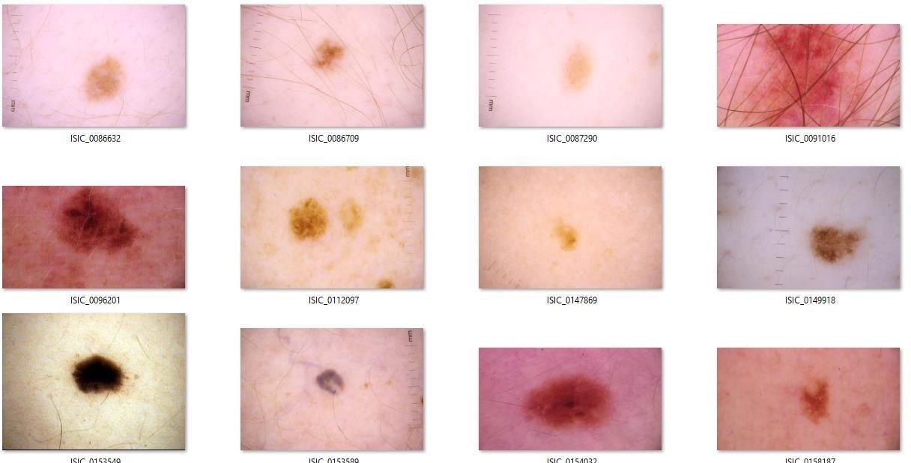

Table of Contents

Introduction
  - 1.1 Objectives

Problem Statement
- Existing and Proposed Solution
  - 3.1 Solution
  - 3.2 Code Submission (Github link)
  - 3.3 Project Submission (Github link)

Methodology
  - 4.1 Dataset
  - 4.2 Data Preprocessing
  - 4.3 YOLOv8 Model Used
  - 4.4 Architecture of the Model (YOLOv8)
  - 4.5 Training
  - 4.6 Evaluation Metrics and Glossary

Results
  - 5.1 Confusion Matrix
  - 5.2 YOLOv8 Results
  - 5.3 Quantitative Results
  - 5.4 Qualitative Results

Discussion
  - 6.1 Interpretation
  - 6.2 Limitations
  - 6.3 Future Work

Conclusion
  - 7.1 Summary
  - 7.2 Impact
- References

Problem Statement
In the assigned problem statement
The project aims to address the challenge of early skin cancer detection, specifically melanoma, which is one of the most dangerous types of skin cancer. Traditional methods, such as visual examination and biopsy, are time-consuming and require significant expertise, making them unsuitable for widespread screening. Therefore, there is a need for automated and reliable diagnostic tools that can assist in the early identification of skin cancer, improving patient outcomes.
This study compares two deep learning models, YOLOv8 and CNN, to determine which is more effective in classifying skin lesions as benign or malignant using the ISIC 2020 dataset.

Existing and Proposed solution

Existing Solutions:
  - Traditional methods for skin cancer detection include manual examination and biopsy, which can be subjective and inconsistent.
  - Early machine learning models like Support Vector Machines (SVM) and Decision Trees required manual feature extraction from images, leading to less accuracy.
  - YOLOv8 have become the standard for image classification tasks, including dermatological applications, providing improved accuracy

Code submission (Github link) :
https://github.com/Saksham9934/upskillcampus-Final- Project/blob/main/Skin%20Cancer%20Detection%20and%20Classification%20using%20YOLOv8%20Mod el.ipynb

- Report submission (Github link) : Skin Cancer Detection Using YOLOv8 Model_Saksham Jha_InternshipReport_USC_UCT.docx
1.1 Objectives
This research aims to:
- Develop and compare the effectiveness of YOLOv8 and CNN models in classifying skin lesions as benign or malignant.
- Utilize the ISIC 2020 dataset to train and validate these models.
- Analyze and compare the performance metrics, including accuracy, precision, recall, and F1 score, to determine the most suitable model for clinical application.

Methodology

Dataset
The ISIC 2020 challenge dataset, a large collection of dermoscopic images labelled as benign or malignant, was used in this study. The dataset comprises thousands of images from multiple sources, annotated by dermatology experts. For our analysis, we used 23,126 images which comprised of two categories benign and malignant. Dataset also had a csv file containing various information of patient and whether the lesion is malignant or benign which further helped in better evaluation of model.

Data Preprocessing
Resizing images to a uniform size, normalizing pixel values, and augmenting the data through techniques such as rotation, flipping, and zooming to enhance the model's ability to generalize is what which is known as data preprocessing. These steps were essential to ensure that the models could handle variations in image quality and lesion appearance. Here, images are resized to 256*256 pixels.

YOLOv8 Model Used
YOLOv8 is an advanced object detection model known for its speed and accuracy. It uses a single neural network to predict bounding boxes and class probabilities, making it suitable for real-time detection tasks. For this study, we adapted YOLOv8 for binary classification of skin lesions.

Architecture of model
YOLOv8's architecture includes multiple convolutional layers, batch normalization, and leaky ReLU activations, followed by fully connected layers that output bounding box coordinates and class probabilities. The model's efficiency lies in its ability to process an entire image in a single pass, making it ideal for applications requiring real-time analysis..

Training
Models were trained using the ISIC 2020 dataset over 20 epochs, with a learning rate of 0.001 and a batch size of 32...

Evaluation Metrics and Glossary
The dataset was divided into train, validation and test data. After training and validating model they are evaluated on the test data.
The models were evaluated using the following metrics:
    - Accuracy: The percentage of correctly classified images.
    - Precision: The proportion of positive identifications that were actually correct.
    - Recall: The proportion of actual positives that were identified correctly.
    - F1 Score: The harmonic mean of precision and recall, providing a balance between the two.
    - Support: The number of instances in each class.

Results
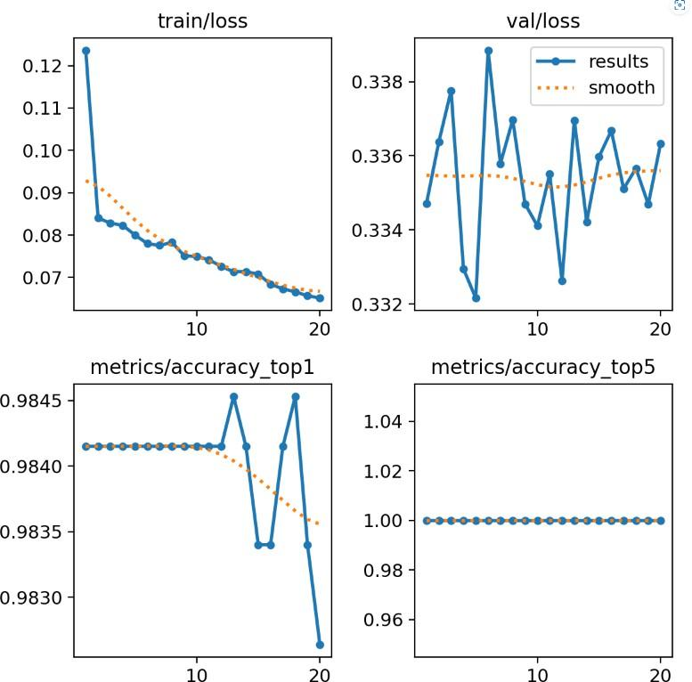

Confusion matrix

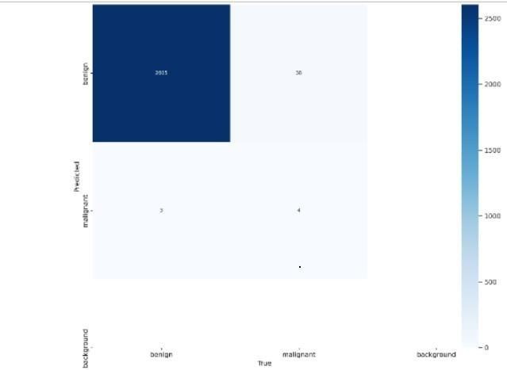
YOLOv8 Results

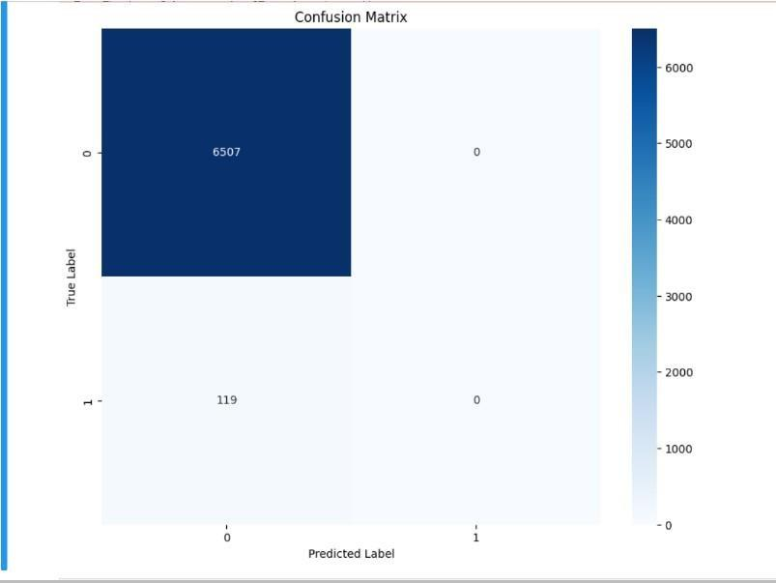

Quantitative Results
The YOLOv8 model achieved an accuracy of 98.5%, with a precision of 0.98, recall of 1.00, and an F1 score of 0.99. The support for malignant lesions was 6,507.

Qualitative Results
Sample predictions from both models demonstrated their ability to accurately classify skin lesions. YOLOv8 consistently provided high-confidence predictions, correctly identifying the boundaries and classifications of lesions, while the CNN model also performed well, albeit with slightly lower precision.

Discussion

Interpretation
The results indicate that both YOLOv8 models are highly effective for skin cancer detection. However, YOLOv8's superior precision and recall, coupled with its ability to process images in real-time, make it more suitable for applications where accuracy and speed are critical. The slightly lower performance of the CNN model may be due to its inability to localize lesions as effectively as YOLOv8, which incorporates object detection capabilities.

Limitations
The study's limitations include the reliance on a single dataset, which may not fully capture the diversity of skin lesions encountered in clinical practice. Additionally, while YOLOv8's real-time capabilities are advantageous, its complexity and resource requirements may limit its deployment in some settings.

Future Work
Future research should focus on expanding the database to include different skin cancers and diseases, a s well as exploring hybrid models that effectively combine YOLOv8 . Additionally, further studies are need ed to integrate these models into clinical practice and ensure that they complement rather than replace the expertise of dermatologists.

Conclusion

Summary
This study explores the performance of the YOLOv8 model in the classification of skin cancer, utilizing the ISIC 2020 dataset, which contains thousands of dermoscopic images. YOLOv8, known for its real-time detection capabilities, demonstrated superior performance compared to traditional CNN models, achieving higher accuracy, precision, recall, and F1 scores. The model's ability to accurately classify skin lesions as benign or malignant highlights its potential as a valuable tool for early skin cancer detection, particularly for melanoma, the most dangerous form of skin cancer.
By leveraging deep learning techniques, YOLOv8 offers a significant improvement in diagnostic accuracy, reducing the need for manual visual examination and subsequent biopsies. The model's real-time processing abilities make it particularly suitable for clinical applications where timely and precise diagnoses are critical. The findings emphasize the potential of deep learning models, like YOLOv8, to revolutionize medical diagnostics, improve patient outcomes, and reduce healthcare costs. Ultimately, the study underscores the role of artificial intelligence in enhancing early detection, enabling more effective treatment interventions, and supporting dermatologists in their clinical decision-making processes.

Impact
The successful application of the YOLOv8 model in this research represents a significant advancement in the use of deep learning for medical diagnostics. By providing rapid, accurate, and efficient skin cancer detection, YOLOv8 can empower healthcare professionals to make quicker and more informed decisions. The model's ability to deliver real-time, high-precision diagnoses facilitates early intervention, potentially improving survival rates, especially for aggressive forms of skin cancer like melanoma.
Furthermore, the integration of automated diagnostic tools like YOLOv8 could alleviate the burden on dermatologists, especially in regions with limited access to specialized healthcare. This not only enhances patient care but also optimizes clinical workflows, reducing diagnostic delays and healthcare costs. The research underscores the transformative potential of deep learning technologies in revolutionizing dermatology and improving public health outcomes on a global scale.

References
    - Esteva, A., Kuprel, B., Novoa, R. A., Ko, J., Swetter, S. M., Blau, H. M., & Thrun, S. (2017). Dermatologist-level classification of skin cancer with deep neural networks. Nature, 542(7639), 115-118.

    - Brinker, T. J., Hekler, A., Enk, A. H., Berking, C., Haferkamp, S., Hauschild, A., ... & von Kalle, C. (2019). Deep learning outperformed 11 pathologists in the classification of histopathological melanoma images. European Journal of Cancer, 113, 47-54.

    - Haenssle, H. A., Fink, C., Schneiderbauer, R., Toberer, F., Buhl, T., Blum, A., ... & Reader Study Level-I and Level-II Groups. (2018). Man against machine: diagnostic performance of a deep learning convolutional neural network for dermoscopic melanoma recognition in comparison to 58 dermatologists. Annals of Oncology, 29(8), 1836-1842.

    - Redmon, J., & Farhadi, A. (2018). YOLOv3: An incremental improvement. arXiv preprint arXiv:1804.02767

    - Bochkovskiy, A., Wang, C. Y., & Liao, H. Y. M. (2020). YOLOv4: Optimal speed and accuracy of object

